Beyond great UFO photos: an inquiry into the Billy Meier case - By Michael Horn
A nondescript farmer in Switzerland purports to have taken the most stunning group of UFO photographs ever. Since the advent of his claimed contacts with ETs from the Pleiades in the mid-'70s, Eduard Billy Meier and his photographs have been alternately revered and reviled, depending on whom you talk to. For the first time in UFO Magazine, a Meier aficionado gets into fundamentals, not photos: "Pleiadian" philosophy—and prophecy.

The Billy Meier UFO case and the controversy that has swirled around has been well known for more than two decades. The case is at least as famous for all the efforts to debunk it as for the amazing photographs that have been the primary target of such attacks. If all that made the Meier case unique were the photos, let alone the film footage, metal samples and sound recordings, the case could remain fodder for those invested, for whatever reasons, in feeding off the controversy.
However, another less well known aspect to the case which in and of itself is quite remarkable, when combined with the totality of the other evidence, makes the case absolutely unique and worthy of serious consideration. Information was given to Meier by his alleged Pleiadian visitors, and published by him over 20 years ago, which has proven to be true and accurate by independent scientific sources with the highest levels of credibility. Such proof is all the more compelling since there is no evidence whatsoever that any of those scientific sources had any knowledge of Meier's information, or that their work would validate the contents thereof.
I wish to first acknowledge my own bias and also present a little background as to my involvement with this material. When I saw the book UFO...Contact From The Pleiades, Volume 1 in 1979 after it first hit the bookstores in Los Angeles, I was fascinated by the apparent authenticity, high quality and clarity of the photos. I was likewise fascinated by the purported existence of highly advanced space-traveling humans and the quotations attributed to them.
There was also a strange sense of familiarity with the material that resonated back to early childhood memories, or perhaps daydreams. I do not know if this was because of the influence of the space hero TV shows I grew up with in the late '40s and '50s, past lives, future lives, cellular memories or simply very wishful thinking. I loved that book and it inspired me.
In 1986, I was in Sedona, Arizona, with a delightful group of women on a kind of New Age field trip. While having lunch in a little cafe with one of the ladies, I noticed the only other customer in the place dining alone, and invited him to join us. Ralph was a former IRS agent who, as it turned out, was also very fascinated with UFOs. As our lively lunch and otherworldly discussion were coming to a close, he invited me to contact him at his Malibu, California, home when I returned to the city.
It turned out that not only did Ralph have the famous Contact from the Pleiades. . .Volume 1 he also had ...Volume 2 and the "Contact Notes," an 1800-plus page copy of a document the existence of which was previously unknown to me.
The "Contact Notes" purported to be the verbatim transcript of the conversations Meier had had with his alleged Pleiadian(1) visitors. The translation was in somewhat fractured English by way of Swiss-German, with each contact dated, each sentence numbered, a challenging but totally engrossing read. Ralph, whose last name was Amagran (or similar, it's been over 12 years) was a great aficionado of the case and generously loaned me the whole transcript.
We became friends and occasionally spent evenings outside his home in the hills overlooking the Pacific Ocean, scanning the star-studded sky for UFOs. We probably spent more time getting excited by the distant approach of incoming Cessnas and seagulls than any two people ever have, before or since. It's a toss-up as to who had the biggest imagination at the time, but Ralph may have finally edged me out. He's since changed his name to Alex Collier and declared himself to be a long time Andromedan contactee. Apparently the Andromedans told him an awful lot of the exact same stuff that the Pleiadians told Meier, which he's suddenly remembered. What a coincidence!
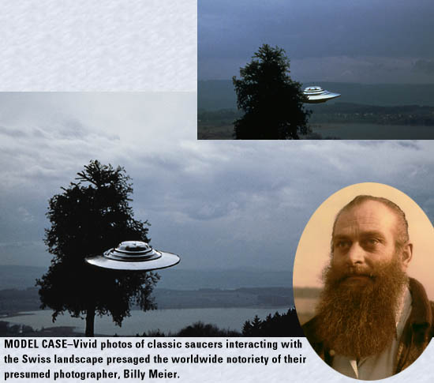
Now, let us at least temporarily abandon the primitive state of mind I call Cargo Cult Consciousness, a reference to the New Guinea islanders who, having built vine replicas of the mysterious gods (airplanes) they saw flying overhead, then worshipped them. We've spent too much time chasing and worshipping lights in the sky (like the two idiots mentioned above) and pondering dubious abduction scenarios (here come the letters!) and too little exploring the significance of not being either alone in the universe or the most advanced beings in it.
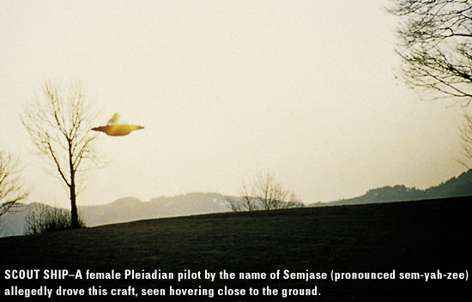
There is no way to prove that the Billy Meier UFO photos, or any other ones, are either genuine or fakes if you firmly believe each respective opposite to be the case. When the first photos in discussion were taken in 1975, very few people had access to the then very expensive equipment necessary to determine their authenticity. Still, that equipment was far more sophisticated than the technology available then, to even the average Swiss farmer, to effectively fake such photos. This was all the more true for the equipment used to analyze the films, metal samples and sound recordings Meier submitted.

Ease of Fakery
Nowadays, not only is the equipment necessary for such evaluations even better, it is far more accessible as, indeed, is the equipment necessary to produce highly convincing fake photos. As a matter of fact, equipment available at your local computer store can probably be used to alter a genuine UFO photo enough to make it appear as a fake. This is one reason why I am less impressed with the critics of the Meier case who can now "prove" that any photos are fakes. Unfortunately or otherwise, because of ever-improving technology, from here on all UFO photos may be dismissed as fakes.
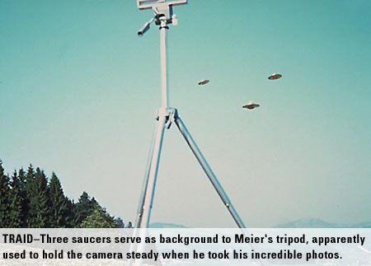
I'm sure by now you would agree that real cases require not only pictures, but also other evidence and substantial content, if they're to be taken seriously. In order to compare cases (apples-to-apples) one should also get all the hard evidence ready from any other case of choice. This should include the professional/scientific evaluation of the metal (or other) samples and the sound recordings, as well as the film (or even video) footage, so that we can see how it compares with Meier's. Let us assume for a moment that there are real UFO photos, perhaps Meier's, or Ed Walters', Carlos Diaz', whomever's-take your pick. Once we accept that, what is the next important issue to consider? For starters: who's flying them, where do they come from, what do they know, what do they want, etc.? The Meier case offers answers to these questions, which we will want to compare with those provided in other UFO case(s), but far more importantly it presents specific, accurate information found in no other case to my knowledge. I am referring to the information I alluded to in the second paragraph of this article. That information is contained in the "Contact Notes," the document which contains the essence of the Meier/Pleiadian message.
So just what is it that sets Meier, this politically incorrect, one-armed, well-armed (.357 magnum), bearded, pro-environmentalist, pro-genetic engineering, anti-Greenpeace, anti-vegetarian, anti-religious, anti-pacifist, conservative, prophesying, meditating farmer and his material, apart from all other purported or self-proclaimed contactees, channels, etc. and their information?

Making The Case
Let's start with a reference to his seventh recorded contact with Semjase (his female Pleiadian ET contact) on February 25, 1975 (sentences 17-43) as well as his 34th recorded contact on Sept. 14, 1975 (sentences 887-932) and 35th contact on September 16, 1975 (sentences 907-921). During these contacts Meier was informed of the dangers facing humankind from the consequences of the human-caused damage to the ozone layer. Acknowledging that terrestrial scientists already knew that emissions from internal combustion engines and gases from spray cans were among contributing factors, Semjase emphasized that of even greater concern was the (at that time unknown to us) damage from the atmospheric atomic testing of the 1940s, 1950s and 1960s as well as bromine gases.
She told Meier that the explosions of the atomic devices released certain "elementary radiations" that, while our scientists didn't even have a means of detecting, were rending holes in the ozone. This was allowing deadly UV rays to pass through, killing off microorganisms in the upper atmosphere as well as microorganisms in the seas (plankton), with which they were in symbiotic relationship. Meier was told that this would ultimately lead to problems with the food chain as well as genetic mutations. Semjase said that bromine gases were also contributing to the destruction and, along with her warnings about these contributing factors, also provided figures on the increased percentage of damage to the ozone layer (6+ percent).
Meier was encouraged by her to contact a Prof. Michael McElroy of Harvard University with this information, which he did but received no acknowledgment or reply. He also disseminated copies to scientists, governments and foreign embassies in Switzerland, receiving only one response, a thank-you from the West Germans. Again, all this was in 1975 when no one else seemed to be publicly discussing these contributing factors, certainly no one-, two- or three-armed farmers (Swiss, American or otherwise), or politicians, professors, scientists, meteorologists, contactees or channels that I've ever heard of.
The first public mention, which I offer as the first example of corroborating information from the scientific community, was found in the following article is from the Santa Monica, California Evening Outlook newspaper, dated Nov. 29, 1988, 13 years after Meier's conversation with Semjase, headlined: ATOM BOMB TESTING TIED TO NUCLEAR DEPLETION.
The next example is from an article in the Los Angeles Times February 24, 1992: Ozone Hole Damages Food Chain.
Semjase also warned Meier that our extraction of petroleum and natural gas from the Earth, and damming of waters, (45th contact February 25, 1976; sentences 60-63), was a major contributing factor to the increase of earthquakes and volcanic activity, much of which we would be experiencing later towards the end of the century. Well, wouldn't you know it, some wise guy professor at Stanford (he's probably the one who helped Billy fake several hundred UFO photos, films, metal samples, sound recordings, etc., in his spare time) comes out with the following: The Good Life-Independent Journal newspapers, during the week of June 21 thru June 27, 1990, reported: Earthquakes, Oil Inter-act
There also was a scientific report aired on National Public Radio, around 1991 or so, during which the "discovery" of the connection between bromine gases and the ozone damage was announced. The report made mention that bromine gases were used extensively in wood treatment, especially woods prepared for export to Japan, fumigation and also for agricultural applications. Bromine gases are now well recognized as damaging to the ozone layer.
The above-mentioned examples bear serious consideration, unless, of course, all one wants to do is go back and argue about whether the photos Meier took are "real." Set aside all the hard evidence for a moment if you wish, the hundreds of photos (only a small few of which have ever been well scrutinized), the films, the metal samples and the sound recordings. Please explain the above information ending up in the remaining hand of a farmer with a sixth grade education, living in the hilly countryside 50 miles outside of Zurich, Switzerland, some 13-17 years before it was first publicly announced, published and attributed to the aforementioned reputable scientific sources.
Perhaps we should compare it to the information from one of the other "real" UFO contact cases, or some channeled information, or maybe the information from some of the brilliant debunkers. Actually, before going any further, maybe we should stop here until we have a real good explanation for these questions: How do you successfully hoax information, in scientific areas outside of your expertise (as a farmer), that will be corroborated in the future by reputable sources? Will the argument now become: "We don't know how he did it but it's unfair, and highly irresponsible, to make your critics look stupid in the process."?

There was other information of a scientific nature given to Meier that pertained to the temperatures, topography and terrain on Venus, percentages of different gases in the Venusian atmosphere, speed and direction of winds, etc. This could arguably have been obtained from other sources, it could also be inaccurate, though I am unaware of any debunking of it to date. Then there are the figures he was given on the age of the Earth and the universe, both so much greater than what terrestrial science recognizes as to make the point irrelevant for discussion. As well, the Pleiadians gave him their chronologies for global ice ages and other subjects that we cannot yet evaluate as to their accuracy. They also included a lot of information about the origin of some of the planetary bodies in our solar system and about comets with great destructive potential, such as the one that the Pleiadians say caused the Great Flood nearly 11,0000 years ago.

Stuff You Can't Prove-Yet
While we're at it, let's touch upon some other areas of information contained in the "Contact Notes" and other Meier papers that, if nothing else, provide food for thought and, again, a chance for us to compare to material in the other cases. As they come to mind, then, in no particular order:

The Man-Monkey Connection
Semjase confirmed Meier's presumption that the Darwinian model of humans descending from monkeys was nonsense. She added that the monkeys were actually the result of a "coupling" between early existing humans (degenerated descendants of earlier extraterrestrials) and another animal. Semjase said that the "intermediate mutations, partly human being/partly monkey," are known to us as "Africanus," "Peking Man" and "Neanderthals." She claimed that, as of 1975, descendants of four different kinds of these mutations existed and are what we call "Yeti." (Seventh Contact February 25,1975 Sentences 117-136)

Abortion
Meier asked if the Pleiadians allowed abortion, and Semjase answered that they did, with natural substances, only up until the third week because that was when they knew that the human spirit was present. Because they had the scientific ability to know that with certainty, they considered an abortion after that time to be murder. Imagine if we knew when the (as yet unrecognized or debated) human spirit was present, wouldn't that put an end to the polarizing pro-/anti-abortion conflict? Or would we still figure out a way to war with each other over it?

Origins of Humans on Earth
Meier was told that human history actually goes back billions of years with origins in the Lyran and Sirian star systems. Many Earth humans are descendants of highly technologically advanced but warlike humans who, long ago and far away, explored the deep reaches of space. They colonized, they plundered, and in some cases such as here, they genetically upgraded the existing primitive human "stock." In other cases, humans brought here had been deliberately genetically engineered to be aggressive fighters for more advanced races in the Sirian system with deliberately genetically limited life spans of less than 100 years. So limited, Meier was told, as to protect the much longer lived "creator gods" from being overthrown through an uprising. Ultimately that genetic manipulation, which they call the true "original sin" was spread to every terrestrial human inhabitant, and conditions us to this day. They say that our scientists are within reach of finding, and reversing, this limiting aging gene. Meier was told that we will regain the multi-hundred year life spans in the near future. Much more about this, and other matters, can be found in the three-part "251st Contact" on Meier's website.

Atlantis
According to the Pleiadians, not only was there a continent of Atlantis, but also a continent of Mu with whom the Atlanteans co-existed until inevitable human conflicts interfered. They claim that the sudden destruction of Atlantis came about in a brief but violent war that also destroyed Mu. Meier was told that scientists from Mu actually mounted a propulsion system on a chunk of asteroid and, on a suicide mission, piloted it down towards Atlantis. Apparently a sudden devastating attack from Atlantis had killed all the inhabitants who couldn't flee in time and virtually melted the surface of the land of Mu. However, as the asteroid entered the Earth's atmosphere above Atlantis at very high speed, it began to break into many pieces which attained tremendous temperatures due to the friction of entry.
These huge, hot chunks rained down upon the continent, hitting it with such force as to crack the earth's crust in many places, causing the Atlantean land mass to sink into the ocean, amid great quakes and eruptions. Bizarre as this may sound, satellite photographs have revealed huge indentations, as if made from the impact of giant rocks, off the coast of the eastern seaboard of the U.S. in an area rumored to have been part of the lost continent. In a talk in Los Angeles in 1996, space scientist David Adair spoke of mounting engines on asteroids as a means of diverting their trajectories. History repeating itself?

The Pyramids
Built by advanced extraterrestrial intelligences, the true date of the pyramids according to the Pleiadians is over 70,000 years. As scientists have been pushing the date of the Sphinx back, perhaps we'll also see reconsideration of the age of the pyramids.

Crop Circles
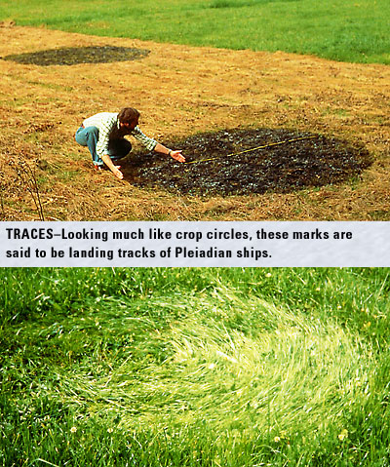
Strangely enough, in a conversation from 1994, Meier and another contact named Ptaah dismiss the authenticity of the crop circles, and attribute them all to hoaxers. This seemed quite ridiculous to me, as the sheer intricacy, complexity and large number of crop circles appearing in sparsely populated areas in a variety of countries eliminates the likelihood of that kind of conspiracy, let alone the immense coordinated skills necessary to fabricate most of them. It should be pointed out that the photographs of the famous "landing tracks" of the Pleiadian ships presented the first close-up look at the "technology" of the crop circles. Semjase told Meier that the landing tracks were created by their beamships' anti-gravitational fields which swirled the grasses down without breaking them.

Something to Think About
It seems to me that "somebody" must have said to themselves, "Hey, let's use this technology to create deliberate patterns for the Earthlings to contemplate. We can incorporate different mathematical and symbolic messages and at the same time demonstrate how to use tremendous power creatively without killing anything!" I could be wrong, but it is ironic that Meier-himself having suffered such abuse from accusations of being a hoaxer-should be so adamant about the crop circles being hoaxed!
For many, another troublesome area of his material is his and the Pleiadians' insistence on his being virtually the only authentic contactee in the world. All others are regarded as cheats, liars, frauds, charlatans, profiteers, etc. I can't prove it either way, though I feel that the Ummo, Itibi-Ra, Carlos Diaz and William Hermann cases seem authentic. Some would add Whitley Strieber, perhaps Robert Morningsky and others. Not so, according to Meier.

Overpopulation
Emphasized over and over in the material are warnings about the numbers of humans on our planet. We are informed and reminded of the tremendous damage we do to our environment and our ourselves by not drastically reducing and then maintaining a manageable population. The point is developed and expanded upon in thought-provoking ways. It involves illegal immigration, mass exoduses and enormous problems that lead to wars, food shortages and other dreadful consequences. The culpability of the religions is clearly pointed out.
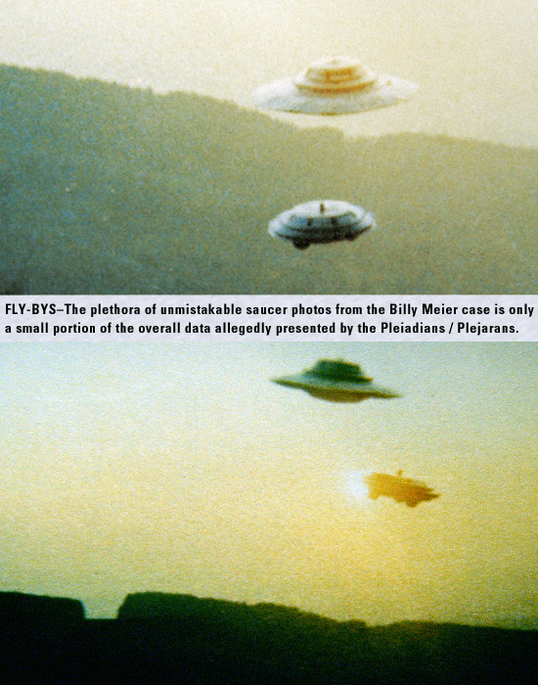

Capital Punishment
The barbarism and shortsightedness of "killing the body" is juxtaposed with the solution championed by Meier and the Pleiadians: Permanent, lifelong removal and exile of killers from society. The case is made that our bloodthirsty lusting for vengeance is spiritually inappropriate, as real isolation accomplishes the goal of protecting society while giving the spirit of the offender time to suffer the loss of freedom, perhaps to contemplate and feel remorse as well.
The Pleiadians say that inflicting death on the killer eliminates the opportunity for the spirit to develop in its understanding while alive and, as they believe in reincarnation, is actually worse for society as the reincarnating killer may repeat murderous tendencies.

The Zetas
Semjase told Meier that the beings that abducted Betty and Barney Hill were from Zeta Reticulum. She described them as highly advanced human types with a scientific agenda and no malice intended towards humankind. Remember, Meier was hearing about, and publishing, this in the mid-1970's, before the Grays were getting much press (good or bad) elsewhere.
The above represents but a very small sampling of the different areas of information contained in Meier's material. Now that he has a website, you can go and check out the material for yourself. I highly recommend the three-part 251st Contact that deals with human history, genetic engineering, etc. Apparently Meier has irritated a lot of people; he's had a lot of potshots taken at him, figuratively and literally, some 17 actual assassination attempts reported to date.
Lee and Britt Elders and Wendelle Stevens, aficionados and commercial representatives of the Meier material, were with Billy sitting on his porch one day when Billy's head suddenly jerked awkwardly to one side as a rifle bullet hit the wall where his head had been a millisecond before. Clearly it wasn't possible for Billy to have deliberately reacted that fast, leading to the possibility that he was afforded some form of protection against assassination, at least for a time. How many "professional" channels, contactees and publicity seekers would still be in business if they had to deal with this level of harassment?
So why all the gunfire directed at a guy who's faking UFO photos? Could it have anything to do with the almost endless criticism of organized religion that peppers the pages of his booklets, tracts, newsletters, publications and "Contact Notes?" It's not only Meier but also Semjase and her father, Ptaah, a Pleiadian leader, who lambaste all the terrestrial religions. Actually, they're pretty much equal opportunity offenders, with something bad to say about virtually every group on the planet, with second helpings for the lowly and contemptuous Americans.

What's It All About, Ralphie?
To say that the Meier case is about UFOs is as accurate as saying the Columbus case was about the Nina, the Pinta and the Santa Maria. They were only the ships that brought the elements of immense change to the New World. The tremendous emphasis that Meier and the Pleiadians place on spiritual reality and development could well be the raison d'être for this whole matter.
For those who've never been exposed to the philosophy the Pleiadians espouse I'll attempt a condensed version based on my current level of understanding. (For the most direct and accurate understanding refer to Meier's material.) The Pleiadians say that our term, God, actually refers to the various technologically advanced extraterrestrial human beings that came here eons ago.
These beings represented themselves to the far more primitive Earth humans as the Creator, or Creators, of all things, like the Biblical God. This has been touched upon in other works by von Daniken, Sitchin and others, but not to the highly detailed extent of the Pleaidian chronologies.

The Creation
The Pleiadians use the term "the Creation" to refer to the all-pervading spiritual energy and intelligence which they say is the living body of this universe (they also say there are literally billions of universes.) The Creation is the all-sustaining force of life that permeates, and is permeated by, all things. Nothing exists that is not created and sustained by it. It is all love, wisdom, logic, knowledge, understanding and compassion and more.
The Creation has no chosen people and no "only begotten son;" it bestows no special dispensation or obligation upon anyone and no intermediaries are necessary for us to direct our attention to it. It doesn't take sides in wars, political elections or football games, and has never, ever demanded the blood of any person be shed, for any reason, in its name. Its laws are immutable and we are meant to learn and live by them in a process of ever-greater evolution.
Within each human being is an element or piece of the Creation, the human spirit, whose purpose, through countless millions of incarnations, is to evolve to a high spiritual state of ultimate reabsorption and co-creation with the Creation itself. We are encouraged to see the Creation in all things and to perceive its existence through the observation of nature as well.

Immanuel
Last, but certainly not least in this sampling, and probably the main reason Meier looks like a walking bulls-eye to a bunch of folks, is his self-proclaimed connection to Immanuel, which entails a revolutionary alternative to Christian history . Meier and the Pleiadians claim that the man known to us as Jesus Christ was never known by that name during his lifetime, a lifetime that did not, despite crucifixion, end on the cross. The man was named Immanuel and he was indeed conceived by Mary with the help of Gabriel, a Pleiadian stationed on Earth at the time, for the purpose of bringing the true Creational teachings to humans who had been spiritually led astray. Immanuel is said to have lived to be over 100 and ultimately died and was buried near Srinegar, India. Interestingly, there is corroboration from other sources, including a book by a German author unknown to Meier that tells a similar story and shows photographs of the tomb. Carved into the tomb are the feet of a person who had once been crucified.
A red flag for many is Meier's apparent claim that his spirit and Immanuel's, as well as that of Enoch, Elijah, Isaiah, Jeremiah and Mohammed, are one and the same, and that he therefore has incarnated many times in the past as a prophet. This is certainly the last straw for many and provides the ultimate opportunity to throw the whole case out.
Meier is not a prophet who profits greatly from his labors. Clearly, many others have done much better financially as a result of his reported experiences than he has. Where would the arch skeptics and other poor critics be without him? Why has this man, who for nearly a quarter of a century has been at the center of the greatest UFO controversy in history, not capitalized on this and taken it all the way to the bank? He probably has a Swiss bank account-he is Swiss, after all-but I mean a real Swiss bank account.
Lee Elders once told me that he was with him when Steven Spielberg (speaking of real bank accounts) called Billy and asked how he made those neat UFO films. According to Lee, Billy told Spielberg, in his inimitable Swiss-English, "Well, when the ships come I point my camera and press the button."
Of course, such an apocryphal story is unprovable. Yet the resources necessary to create all the evidence, the money, the manpower, the sheer immensity of the undertaking seem to far exceed the capabilities of the known participants.
Still . . . Let's face it. Everybody knows at least one half-educated, barely self-supporting one-armed farmer, thousands of miles from Hollywood, who dabbles with beyond-studio-quality special effects, sophisticated futuristic metallurgical alloys and irreproducible sound effects, publishes volumes on environmental and atmospheric sciences, convoluted human genealogies, social sciences, genetic engineering, human-machine hybrids, hyper-space travel, time travel, tachyon and light emitting beam-drive propulsion systems, sacrilegious claims and lofty spiritual information . . . in between milking cows.
Jesting aside, the one certain thing in the Meier case is that the main emphasis of the Pleiadian message is spiritual development, truth, individual responsibility, environmental responsibility and population control. It is loaded with warning signs and predictions of the dire consequences of irresponsible human behavior. It seems to have several built-in safety valves, like the Immanuel connection, that seem to function to prevent us from having to believe it. It isn't about worshipping UFOs, space brothers, ascended masters, saints, saviors, blessed virgins or charismatic leaders.

The Four Possibilities
Here are the only possibilities in this case: What Meier is telling us is either, all, mostly, partly or not at all true. There it is. I can truthfully tell you that no body of work I've encountered has had as much of an effect on me as this case-and I don't agree with, or even believe, all of it. I do believe UFO interested people owe it to themselves to find out what the case is about for themselves.

Questions
Don't believe the skeptics and the debunkers, and don't believe those with a bias towards the case like me, but do ask yourself a couple of questions, among them:
What if there is a case whose purpose is not simply to provide opportunities to debate UFO photos, but actually to inform and assist humanity without directly interfering with its evolutionary development? Will we have missed an opportunity to explore, with openness and curiosity, the possibility that there's at least one group of slightly more advanced beings out there who may know more about life's mysteries, and us, than we know ourselves? Or will we insist on proving that we have cornered the market on acquisitiveness, ignorance, egotism and arrogance, fighting to dominate each other, destroying our home and trying to "get somewhere," while we float through space on our cosmically barely significant little piece of lint?

Author's note: I assume that the reader has some knowledge of the facts, as well as the controversy surrounding, this case. I refer to the other evidence, the film, metal samples and sound recordings, because they were evaluated scientifically with the best available technology at the time. The 8mm film footage, where the ship is seen to disappear within one frame (1/25th of a second) and later reappear within one frame (1/25th of a second) was analyzed by Nippon Television. They found no evidence of hoaxing, but the way the ships moved in one sequence or another bothered some people because it didn't fit their expectations. The late Marcel Vogel, at the time a scientist at IBM in Switzerland, evaluated the metal samples. The sound recordings were evaluated at two sound labs, one in Hollywood, California, the other at the Groton Naval Undersea Base in Connecticut. They were deemed in all cases to be not duplicable with the technology available to any of the examiners in any of the facilities at the time. The results were published and, in the case of the metal samples, a videotape was made which is available from Genesis III.
Also, I wish to emphasize that the above article conveys my personal understanding of the material contained in this case, and may or may not coincide completely with the precise body of information the Pleiadians purportedly transmitted to Eduard "Billy" Meier. For more information on all aspects of the Billy Meier case, go to www.figu.ch.

NOTE
1) Now referred to by Meier as Plejarans or Pleiadians/Plejarans for reason of identifying the authenticity of information that purports to be from the same sources as Meier's.
Michael Horn is the co-producer of "The Pleiadian Connection" videotape, the associate producer of "Technical Remote Viewing Home Study Course," composer of "Spaceship On The White House Lawn," "The Ballad of Roswell" and other irreverent New Age songs.
UFO Magazine acknowledges FIGU for granting us permission to use all of their photos.
(Reprinted with kind permission of UFO Magazine, Volume 14, No. 3).

